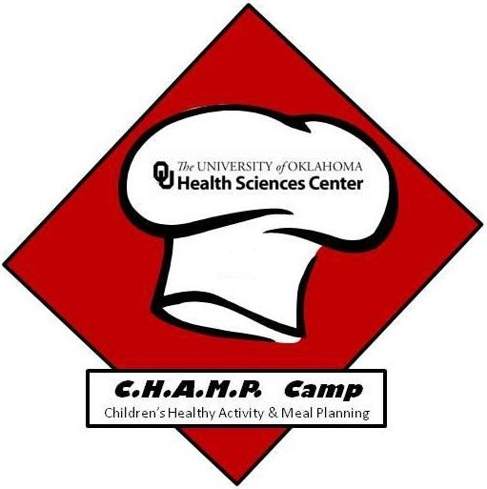
Name:______________________________

Champ Camp Post-Test

- How many types of dietary fiber are there?
  - 1
  - 2
  - 3
  - 4

- Which food is a good source of fiber?
  - Oatmeal
  - Frosted Flakes cereal
  - Cheetos
  - Lunchables

- What one of these will help you get all of your vitamins and minerals?
  - Only eating fruit
  - Eating a well balanced diet
  - Only eating vegetables
  - Only eating protein

- Which protein is plant based?
  - Fish
  - Steak
  - Soy
  - Eggs

- What does the formation of carbon dioxide gas do while baking foods like bread or cake?
  - It gives flavor to the food
  - It makes the food light and fluffy
  - It makes the food more dense
  - It doesn’t do anything to help

- How do high temperatures affect molecular bonds in foods?
  - The bonds will break apart and make the food soft
  - The bonds will strengthen and make the food more stiff
  - High temperatures don’t do anything for cooking
  - Foods don’t have molecular bonds

- You can get sick from raw meat and uncooked fruits and vegetables?
  - True
  - False

- Why do we need to wash our hands before we eat or handle food?
  - To prevent illness
  - To avoid cross-contamination
  - To keep our food germ free
  - All of the above

- Which of the following can help you stay hydrated?
  - Choose sugary beverages like soda and juice
  - Only drink water at lunch
  - Carry a water bottle with you are refill it throughout the day

- What material makes up most of our body?
  - Bones
  - Muscle
  - Fat
  - Water
- What makes up the majority of ice cream?
  - Air
  - Milk
  - Sugar
  - Water

- What main ingredient of homemade ice cream helps freeze the milk to turn it into ice cream?
  - Sugar
  - Water
  - Pepper
  - Salt
- Which one of these would be a good amount of protein servings to eat every single day?
  - Boys and Girls: 6 servings
  - Boys and Girls: 3 servings
  - Boys and Girls: 8 servings
- Which one of these would be a good number of vegetables servings to eat every single day?
  - Boys and Girls: 1 serving
  - Boys and Girls: 3 servings
  - Boys and Girls: 8 servings
- What is NOT one benefit of being sustainable?
  - Reducing pollution
  - Reducing trash going into the landfill
  - Making healthier environments for animals and fish
  - Use up resources

- What is one step of mindful eating?
  - Eating everything off your plate
  - Taking a small portion of food, then getting more
  - Watching TV while you eat
  - Rushing to eat

- True or False, Our bodies can get Vitamin D from the sun.
  - True
  - False

- What mineral is the most common in an American diet?
  - Sodium
  - Potassium
  - Vitamin A

